### Project Summary

**Objective:**

This project aims to develop a fully functional To-Do List web application using the Vue.js frontend framework, Django backend framework, and PostgreSQL database. The application is designed to enable users to create, manage, and share to-do lists.

**Features:**

* User registration and login
* To-do list creation, editing, and deletion
* Individual to-do item addition, completion, and deletion
* To-do list sharing and collaboration (**Not included in the current scope)**
* User profile management
* Responsive design
* RESTful API

**Technologies Used:**

* **Frontend:**
  + Vue.js 3 framework
  + ViteJS build tool
  + Vuex store management
  + Axios library (API communication)
  + Bootstrap CSS framework
* **Backend:**
  + Django 4.1.7 framework
  + Python 3.11 programming language
  + PostgreSQL database
* **Authentication:**
  + JWT (JSON Web Token)
* **Deployment:**
  + Docker
  + Nginx
  + Gunicorn

### Development Process

#### 1. Planning and Initial Setup

* Analyze project requirements and define functionalities
* Select technology stack and development tools (ViteJS, Vue.js, Vuex, Axios, Bootstrap, Django, PostgreSQL, Docker, Nginx, Gunicorn)
* Set up Git version control system (GitHub, etc.)
* Configure project structure and directories
* ERD
* 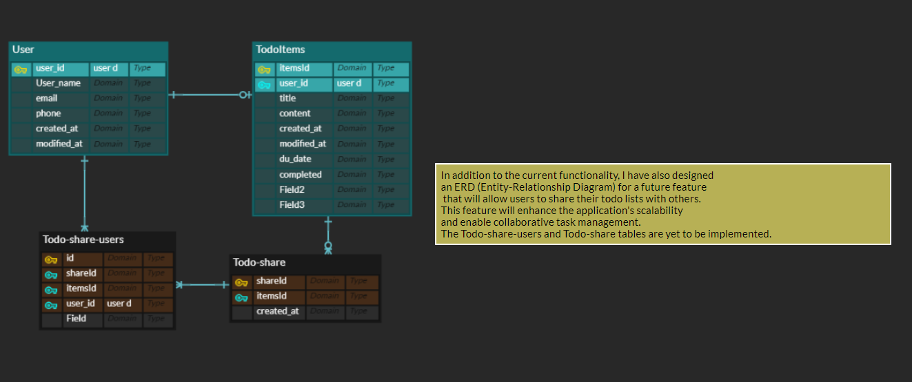

#### 2. Frontend Development

* Implement user interface using Vue.js 3 framework
  + Build reusable UI components using Vue components
  + Manage application routing and page navigation with Vue Router
* Utilize ViteJS build tool for efficient development and build environment
  + Leverage fast hot reloading capabilities
  + Generate optimized builds
* Vuex store management system to handle application state
  + Store user information, to-do lists, UI settings, etc.
* Use Axios library to communicate with Django backend API
  + Send API requests, process responses, and handle errors
* Implement responsive design using Bootstrap CSS framework
  + Adapt UI for various devices

#### 3. Backend Development

* Implement RESTful API using Django 3.2 framework
  + Develop user management, to-do list management, and API endpoints
* Utilize PostgreSQL database for data storage and management
  + Store user information, to-do lists, and other data
* Define database schema using Django models
  + Use model classes to define data structure and relationships
* Build API endpoints using Django REST framework
  + Implement API functionalities using serializers, views, URL patterns, etc.
* Implement user authentication and authorization with JWT system
  + Handle user login, token issuance, and authenticated request processing

#### 4. Frontend-Backend Integration

* Invoke Django backend API from Vue.js application
  + Send API requests using Axios library
* Update frontend UI using API response data
  + Update Vuex store and render UI accordingly
* Handle errors and exceptional situations
  + Process API errors, network errors, and notify users

#### 5. Authentication Implementation

* Implement user registration and login functionalities
  + Utilize Django REST framework's authentication backend
  + Store user information, issue tokens, and manage sessions
* Implement JWT token-based authentication

#### 6. Additional Feature Implementation (Optional)

* Implement user profile management functionality: Enable users to modify profile, names, emails, etc.

#### 7. Deployment

* Configure Nginx web server
  + Modify Nginx configuration file to serve frontend application static files
  + Set up proxy to Gunicorn WSGI server
* Configure Gunicorn WSGI server
  + Modify Gunicorn configuration file to run Django backend API
  + Receive and process requests from Nginx proxy server
* Dockerize application
  + Isolate Vue.js frontend application, Django backend API, Nginx web server, and Gunicorn WSGI server into separate Docker containers
  + Use Docker Compose to automate container connections and execution
* Deploy to production environment
  + Deploy Docker container images to the production server
  + Run containers and start the application using Docker Compose

Challenges Faced:  
Outline any difficulties or challenges you encountered during the development process and how you addressed them.  
  
Code Structure and Quality:  
Evaluate the structure and quality of your code. Discuss whether it is well-organized, readable, and follows best practices. Provide examples if necessary.  
  
User Experience:  
Assess the user experience of your application. Discuss its responsiveness, intuitiveness, and any feedback mechanisms implemented.  
  
Deployment and Instructions:  
Detail the deployment process of your application, including the chosen platform and any deployment scripts used. Provide clear instructions on how to run the application locally.

## Running the To-Do List Web Application Locally

**Prerequisites:**

* Git installed and configured
* Docker installed and running
* GitHub account (optional)

**Steps:**

1. **Clone the Git Repository:**

git clone <https://github.com/kevin-kidong-lim/todolist.git>

1. **Navigate to the Project Directory:**

cd todolist

1. **Pull Docker Images:**

docker pull ultrax00/todolist-postgres:latest

docker pull ultrax00/todolist-front:latest

docker pull ultrax00/todolist-back:latest

1. **Start Containers:**

docker-compose -f docker-compose.dev.yml up –d

docker ps -a



1. **Verify Application:**

Open a web browser and navigate to http://localhost:9999/todologin to access the To-Do List web application.

Additional Comments:  
Feel free to add any additional comments, insights, or improvements you would make if given more time.

**While I successfully implemented the core functionality of the To-Do List application within the allotted time, I recognize that additional features and enhancements could have been incorporated. With more time, I would have focused on implementing user-to-user task sharing, time estimation and tracking capabilities, and further code refactoring to improve maintainability. Additionally, I regret not allocating more time to developing comprehensive test cases to ensure the application's quality and reliability.**

**1.Login**

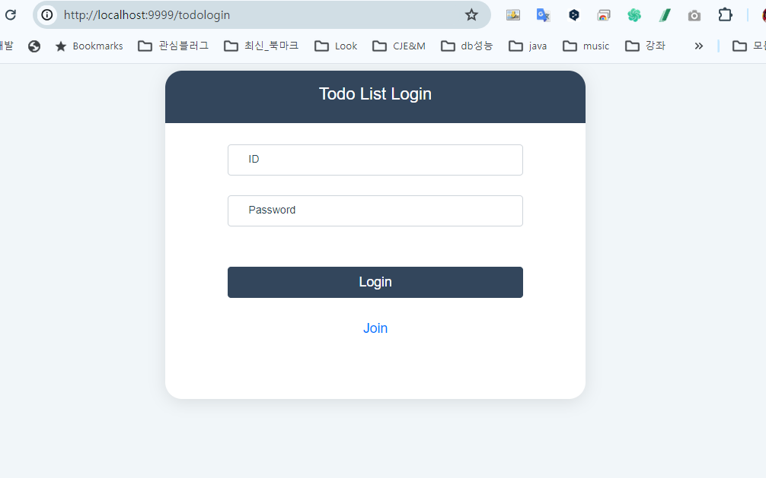

**2.Register**

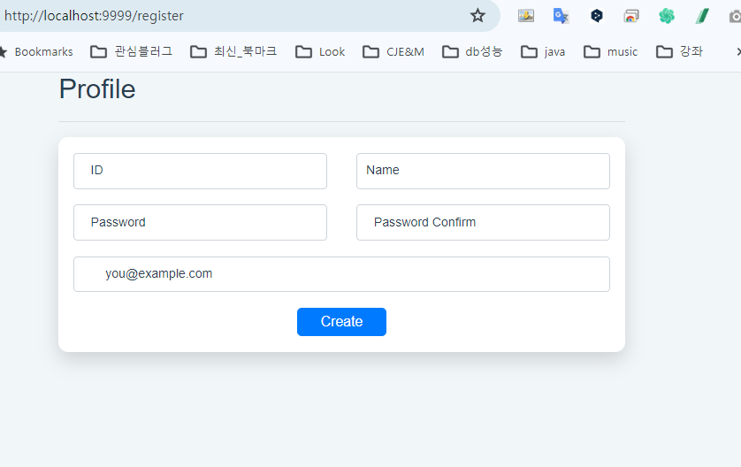

**3.TodoList > Add**

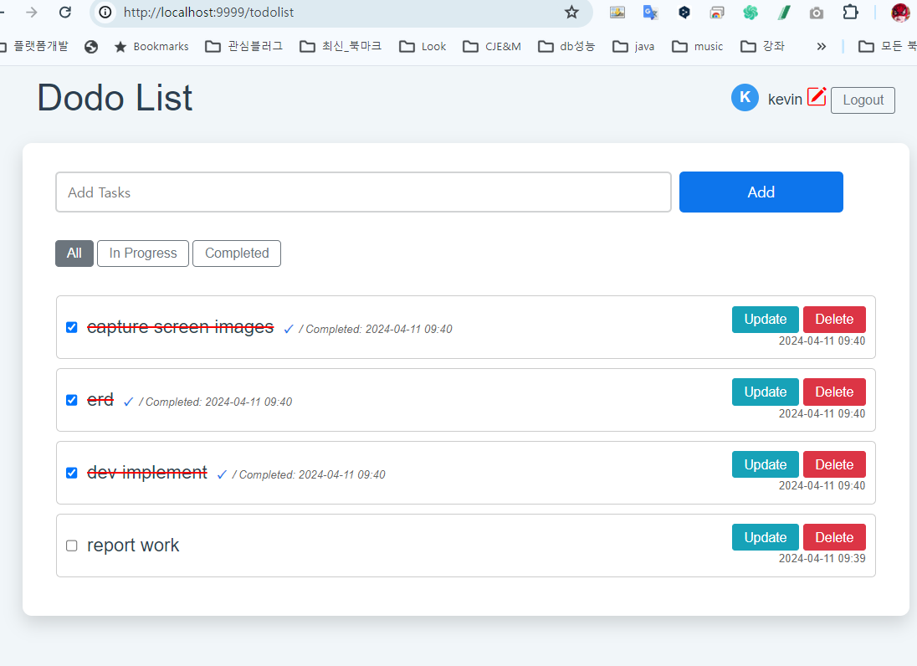

**4.TodoLst > Update**

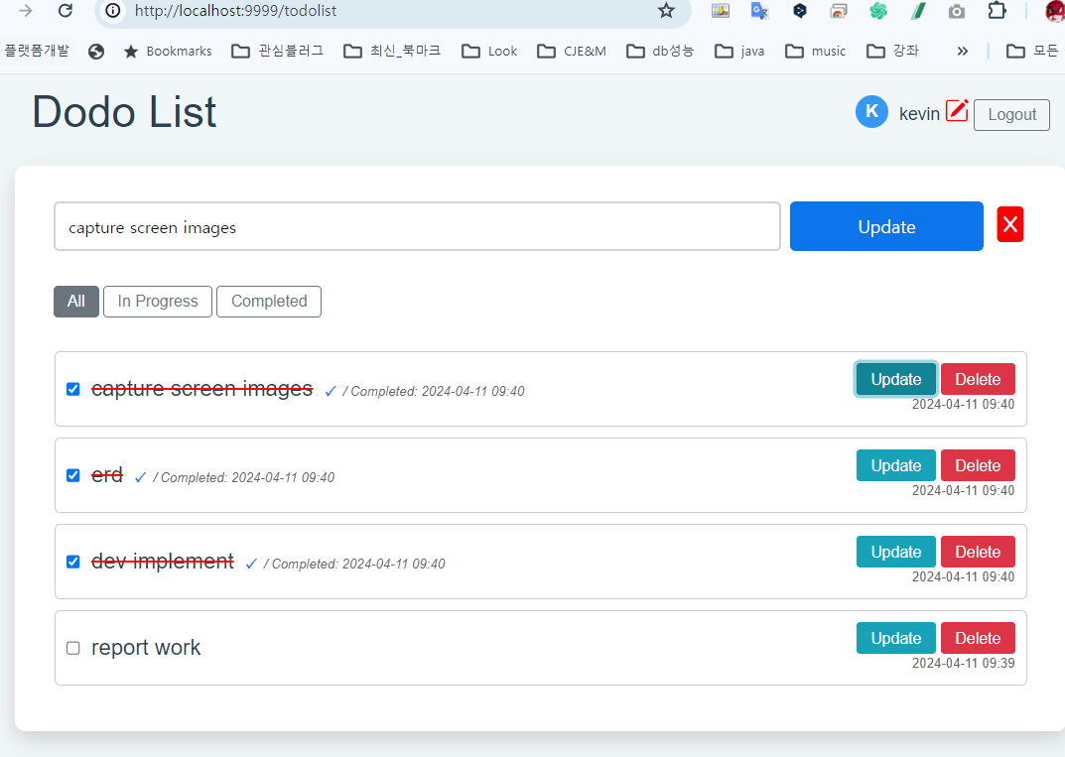

**5.TodoList > filter**

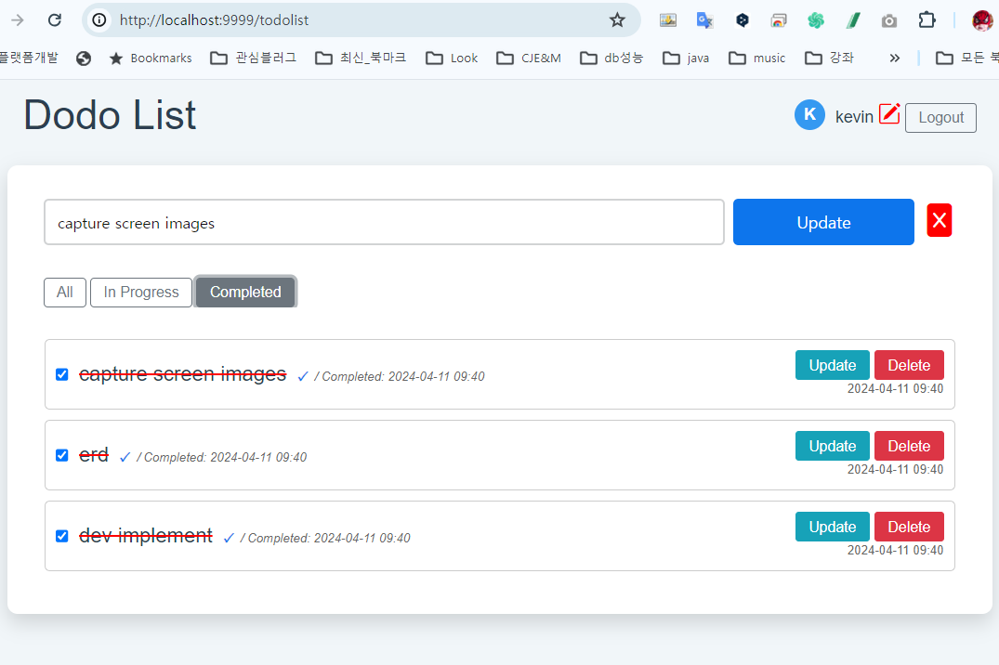

**6.TodoList > profile update**

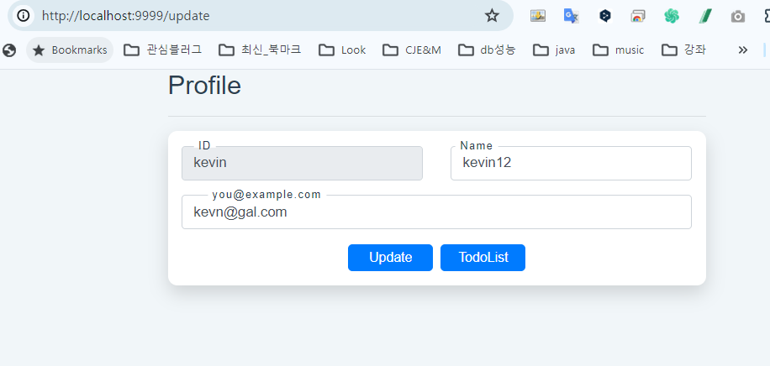

Submission Guidelines:  
Please submit your report as a PDF document along with any necessary files (e.g., code snippets, screenshots). Ensure your report is well-organized and clearly written.  
  
Deadline:  
Please submit your report by Thursday April 11. If you have any questions or need clarification, don't hesitate to reach out via email.